General Biology Year 11 2021


Unit 1 - Classification and cell processes
Task 4: Extended Response – Photosynthesis
(weighting 10%)

Name: | Teacher: | Date: | Score:  /14

Conditions

Time for the task:
- Part 1: One lesson to research topic and complete notes at home.
- Part 2: One lesson for in-class validation – extended response exam style question.

PART 2: In-class assessment

Answer all questions in the space provided.

- Plants make their own food that is important not only for the plants themselves, but for the other organisms that feed on the plants. Explain how plants make food? (3 marks)

_____________________________________________________________________________________________________________________________________________________________________________________________________________________________________________________________________________________________________________________________________________________________________________________________________________________________________________________________________________________________________________________________________________

- Limiting factors of photosynthesis reduce yields of crops and other economically important plants. Explain what plant growers can do to:

a) increase carbon dioxide in a growing area (2 marks)
____________________________________________________________________________________________________________________________________________________________________________________________________________________________________________________________________________________________________________

b) increase temperature in a growing area (2 marks)
____________________________________________________________________________________________________________________________________________________________________________________________________________________________________________________________________________________________________________

- Use the graph below to answer the following questions.

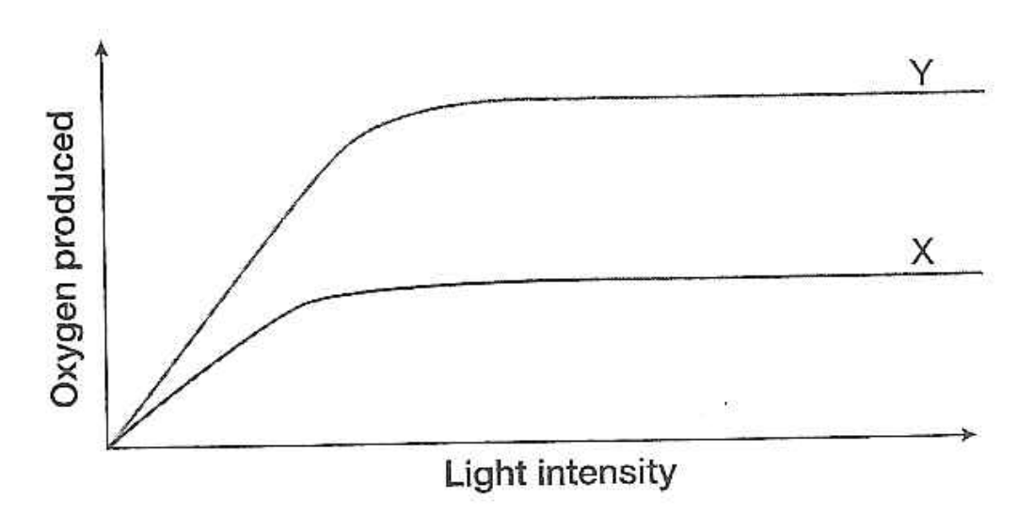

- What can you conclude from this graph? What happens to the rate of photosynthesis in X and Y as the light intensity increases? (1 mark)
______________________________________________________________________________________________________________________________________________

- Explain how can plant growers use this information to increase the growth of crop?
(2 marks) ____________________________________________________________________________________________________________________________________________________________________________________________________________________________________________________________________________________________

- Plants with C4 photosynthesis have a competitive edge over plants with C3 photosynthesis.

a) Explain this statement. (2 marks)
____________________________________________________________________________________________________________________________________________________________________________________________________________________________________________________________________________________________________________
b) Using an example, state how plant growers can use this information to increase the growth of crop? (2 marks)
_____________________________________________________________________________________________________________________________________________________________________________________________________________________________________________________________________________________________________________

End of assessment

